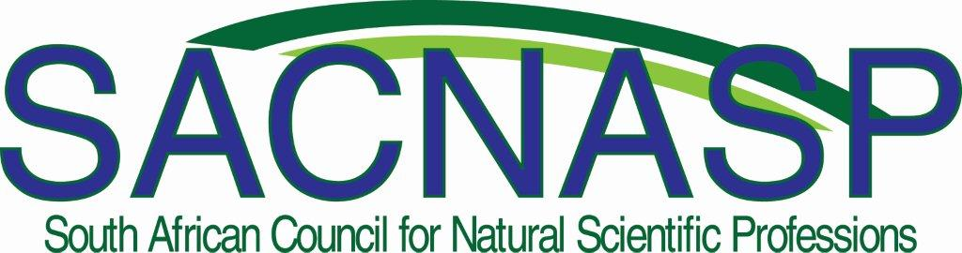
Revised SACNASP Code of Conduct for the comment of Registrered Natural Scientists by 28 February 2018
The Council has drawn up the following Code of Conduct with which registered persons must comply. Failure to do so constitutes improper conduct.

In practicing their natural science professions, Candidate, Certificated
and Professional Natural Scientists must:

1. Have due regard for public safety, public health and public interest generally.
2. Have due regard for harmful practices that may negatively impact the natural environment or local communities.
3. Discharge their duties to their employers or clients efficiently and with integrity.
4. Behave in such a way as to uphold the dignity, standing and reputation of the natural scientific professions.
5. Only undertake natural scientific work for which their education, experience or background have rendered them competent to perform.
6. Disclose, to their respective employers or clients, in writing:
(a) Any interest which they may have in any company, firm or organisation, or with any person, which is related to the work which they may be or may have been employed to perform; and
(b) Particulars of any royalty or other financial benefit which accrues or may accrue to them as a result of such work.
7. Not deliberately injure directly or indirectly, the professional reputation, prospects or business of another registered person.
8. Not knowingly attempt to supplant another registered person after a formal offer of employment has been made.
9. Not advertise their professional services in a self-laudatory manner or in a manner that is derogatory of the dignity of the profession.
10. Not knowingly misrepresent or permit misrepresentation of their own or their associates' academic or professional qualifications, nor exaggerate their own degree of responsibility for any work of a natural scientific nature.
11. Give due recognition when using the work of others, including associates.
12. Not destroy calculations, documentary or any other evidence required for the verification of their work.
13. Not personally, or through any other agency, attempt to obtain consulting work by way of intimidation, threat or bribery.
14. When practicing their professions in another country, they will do so in accordance with these rules in so far as they are not inconsistent with the law of the country concerned; provided that they shall also adhere to the standards of professional conduct in that country.
15. Those members that work with humans, any vertebrate and invertebrate animals and/or material thereof, are required to obtain ethical clearance for the work that they undertake from properly constituted and NHREC registered Human Research and Animal Ethics Committees, adhere to the requirements of the Human and Animal Ethics Code of Conduct and provide the reference number of their ethical clearance on all reports produced or other publications.

